Jain Prayers of Universal Obeisance, Forgiveness,
Peace, and Friendship
Universal Obeisance Prayer
• Namo Arihantanam
• Namo Siddhanam
• Namo Airiyanam
• Namo Uvajjhayanam
• Namo Loe Savva Sahunam
• Eso Panch Namokaro, Savva Pava Panasano
• Mangala Nancha Savvesim, Padhamam Havai Mangalam
I bow to all enlighten beings (Arihants) who have attained perfect knowledge, vision, bliss, and power and have shown the proper path of liberation that is Right Knowledge, Right Perception, and Right Conduct; which brings the cycles of birth, death, and misery to an end.
I bow to all liberated souls (Siddhas) who have attained the state of perfection and immortality by following the path of liberation and achieving freedom of all karma.
I bow to the head of the religious congregations (Acharyas), who follow the path of liberation, preach the principles of religion, and inspire us to live moral and spiritual life.
I bow to the ascetic teachers (Upadhyayas) who explain the true nature of the soul and karma from the religious scriptures and show us the importance of the spiritual life over the material life.
I bow to all ascetics who strictly follow the five great vows of conduct, which are total nonviolence, truthfulness, non-stealing, celibacy and non-possession; and inspire us to live a simple life.
To these five types of great souls I offer my obeisance. May such obeisance help diminish my transgressions and sins. Giving this praise is the most auspicious as to bring happiness.
Universal Forgiveness Prayer
Khamemi Savve Jiva, Savve Jiva Khamantu Me,
Metti Me Savve Bhuyesu, Veram Majham Na Kenai.
I grant forgiveness to all living beings. May all living beings grant me forgiveness.
My friendship is with all living beings. My enmity is totally nonexistent.
Universal Peace and Friendship Prayer
Shivmastu Sarva Jagatah, Par hit nirata bhavantu bhutaganah,
Doshah Prayantu Nasham, Sarvatra Sukhi bhavantu lokah.
May the whole Cosmos be blessed. May all beings engage in each other's well beings.
May all weakness, sickness and faults diminish and vanish. May everyone and everywhere be healthy, prosper, blissful, and peaceful.

Navkar Mantra in Chinese
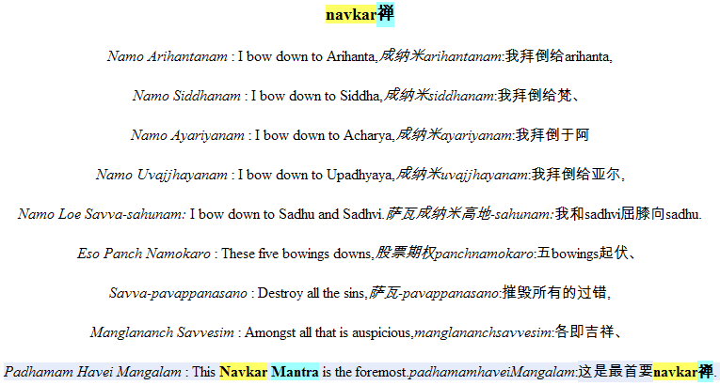
Navkar Mantra in French
INCANTATION DENAVKAR
Namo Arihantanam : Je me suis prosterné devant Arihanta,
Namo Siddhanam : Je me suis prosterné devant Siddha,
Namo Ayariyanam : Je me suis prosterné devant Acharya,
Namo Uvajjhayanam : Je me suis prosterné devant Upadhyaya,
Namo Loe Savva-sahunam : Je me suis prosterné devant Sadhu et Sadhvi.
Eso Panch Namokaro : Ces bas de cinq cintrages,
Savva-pavappanasano : Détruire tous péchés,
Manglananch Savvesim : Parmi le tout ce qui est propice,
Padhamam Havei Mangalam : Cette incantation de Navkar est la première

Navkar Mantra in Portugese

Navkar Mantra in Arabic

Navkar Mantra in German

Navkar Mantra in Italian

Navkar Mantra in Korean

Navkar Mantra in Russian

